1. as treatment level increases life time of the insulation increases

2.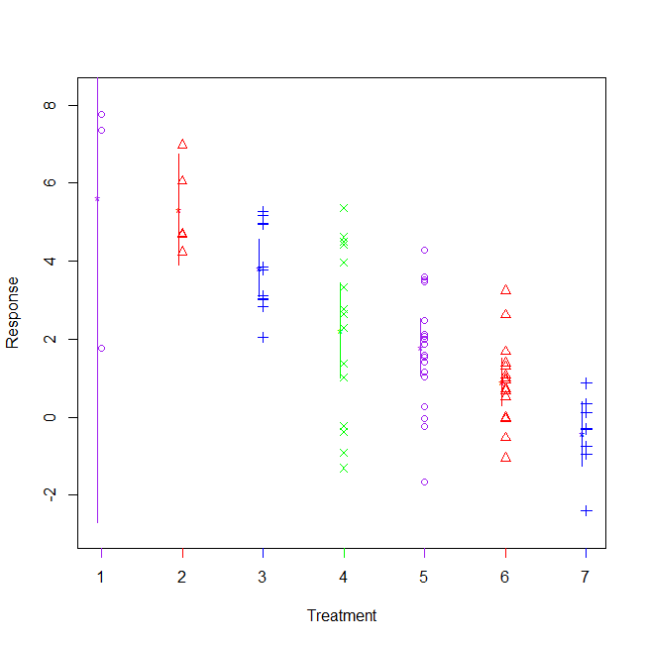

Quite a lot of data is outside the boxplots for each treatment

The first data point is very long due to outliers

The confidence interval of 2 is about 5

No, we do that think that the two treatments.

3.

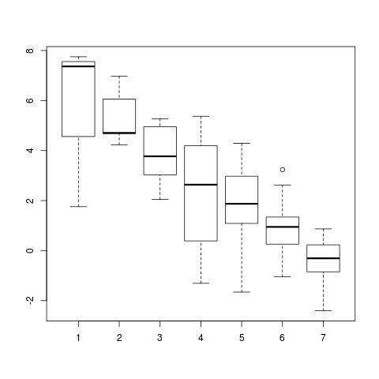

It looks as more of the insulations are treated the lifetime of the insulation is slightly larger. excluding treatment 1 since it only had 3 tests

4.

Analysis of Variance Table

Response: lifetime

Df Sum Sq Mean Sq F value Pr(>F)

factor(treat) 6 196.48 32.746 13.004 8.871e-10 \*\*\*

Residuals 69 173.75 2.518

---

Signif. codes: 0 ‘\*\*\*’ 0.001 ‘\*\*’ 0.01 ‘\*’ 0.05 ‘.’ 0.1 ‘ ’ 1

We acceptH0 because the p-value is extremely small

5.

Kruskal-Wallis rank sum test

data: lifetime by factor(treat)

Kruskal-Wallis chi-squared = 38.3755, df = 6, p-value = 9.486e-07

We accept because the p-value is very small and does not support an alternative.

6.

Tukey multiple comparisons of means

95% family-wise confidence level

Fit: aov(formula = lifetime ~ factor(treat))

$`factor(treat)`

diff lwr upr p adj

2-1 -0.2944527 -3.813956 3.2250503 0.9999761

3-1 -1.8019785 -4.940962 1.3370049 0.5898730

4-1 -3.3954600 -6.443439 -0.3474810 0.0193430

5-1 -3.8375840 -6.831612 -0.8435558 0.0040623

6-1 -4.7217307 -7.769710 -1.6737517 0.0002468

**\*7-1 -6.0483029 -9.310969 -2.7856363 0.0000073**

3-2 -1.5075258 -4.106851 1.0917994 0.5780702

4-2 -3.1010073 -5.589672 -0.6123429 0.0057451

5-2 -3.5431314 -5.965419 -1.1208433 0.0006323

6-2 -4.4272780 -6.915942 -1.9386136 0.0000178

**\*7-2 -5.7538503 -8.501261 -3.0064391 0.0000004**

4-3 -1.5934815 -3.506533 0.3195700 0.1649729

5-3 -2.0356056 -3.861474 -0.2097372 0.0191968

6-3 -2.9197522 -4.832804 -1.0067006 0.0003177

**\*7-3 -4.2463244 -6.485651 -2.0069978 0.0000044**

5-4 -0.4421240 -2.106682 1.2224342 0.9835356

6-4 -1.3262707 -3.086022 0.4334808 0.2642232

7-4 -2.6528429 -4.762711 -0.5429750 0.0051523

6-5 -0.8841466 -2.548705 0.7804116 0.6744233

7-5 -2.2107189 -4.241869 -0.1795686 0.0241447

7-6 -1.3265722 -3.436440 0.7832957 0.4811977

7.

